HW 3 Multinomial Choices

Yaxuan Jiao

3/21/2019

Exercise 1 Data Description

* Average and dispersion in product characteristic

I made a table that includes the average of product prices, the range, variance, standard deviation and interquartile range (IQR=Q3-Q1).

According to the table below, PFl_Tub has the highest average price among ten products. In general, tub appears to be more expensive than stick, and the Fleischmann’s cheese produce the products with the highest average price in both tub and stick category. Besides, the price of ten products are relative stable, with small variance, standard deviation and price range.

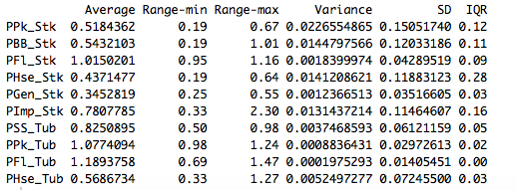

* Market share, and market share by product characteristics
  + Market share by products

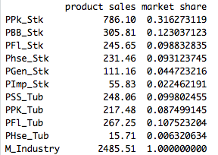

* + Market share by brands

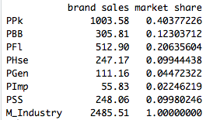

* + Market share by stick and tub

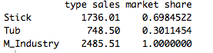

* Mapping between observed attributes and choices
  + Frequency of buying each choice for each income level

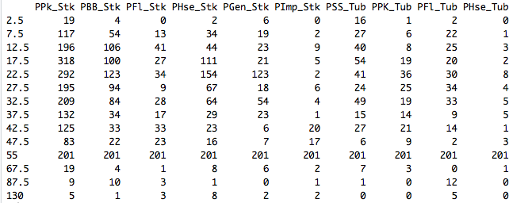

* + Frequency of buying each choice for each family size

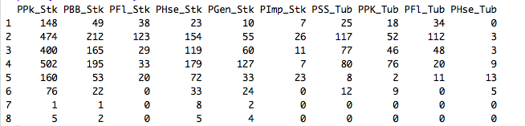

* + Frequency of buying each choice for college and non-college



* + Frequency of buying each choice for white-collar and non-white-collar



* + Frequency of buying each choice for retired and not retired



Exercise 2 First Model

* Apply conditional logit model to capture the choice’s characteristics---the effect of price on demand (since price varies over alternatives)
* Write the likelihood and optimize the model (see code)
* Interpret the coefficient on price
  + optimized coefficients on price: ()



I think this result may vary with the initial values being assigned to beta and alpha, while in terms of this result, I think the negative sign of the estimated coefficient indicates that holding other product characteristics constant, consumers will be less likely to buy cheese products for an increase in price.

Exercise 3 Second Model

* Apply multinomial logit model to capture the chooser’s characteristics---the effect of family income on demand (since family income do not vary over alternatives)
* Write the likelihood and optimize the model (see code)
* Interpret the coefficient on family income
  + optimized coefficient on price:

( )



This result may vary with the initial values being assigned to beta and alpha, while in terms of this result, for example, the positive sign of indicates that people are slightly more willing to buy product 1 when their income increase. And for the negative sign of , I think it means that consumers will be less likely to buy this product for an increase in their family income.

Exercise 4 Marginal Effects

* Compute and interpret the marginal effects for the first (conditional logit) model

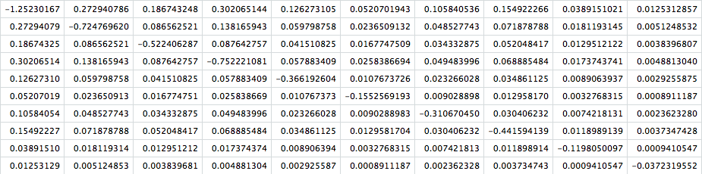

As we can perceive from the table, marginal effects on the diagonal is negative, it’s consistent with the real life intuition that when the price of the chosen product 1 increase, it's less likely for the person to still choose that product 1; however, when the price of other products increase, it will only increase the probability of choosing product 1 a little bit.

* Compute and interpret the marginal effects for the second (multinomial logit) model



According to the results, an increase in family income will have slight effects on the product demand, and I noticed that for products with relatively lower average prices, such as product 4, 5, 6, 7, and 10, they tend to encounter a negative marginal effect from the increase in family income. I think it may because that when people are having higher income, they are more eager to live a higher quality life, so that they may want to buy more expensive products to express their willingness.

Exercise 5 IIA (mixed logit)

* Apply mixed logit model to capture the effect of price and family income on demand
  + Write the likelihood and optimize the model (see code)

: (; )(#30)



* Consider an alternative specification by removing data from one choice
  + Write the likelihood and optimize the model (see code)

: (; )(#27)



* Compute the test statistics:

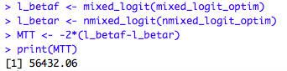

* Conclude on IIA

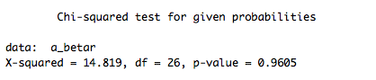

we reject the null hypothesis with strong evidence, and able to conclude that the property of independence of irrelevant alternatives holds in the model.